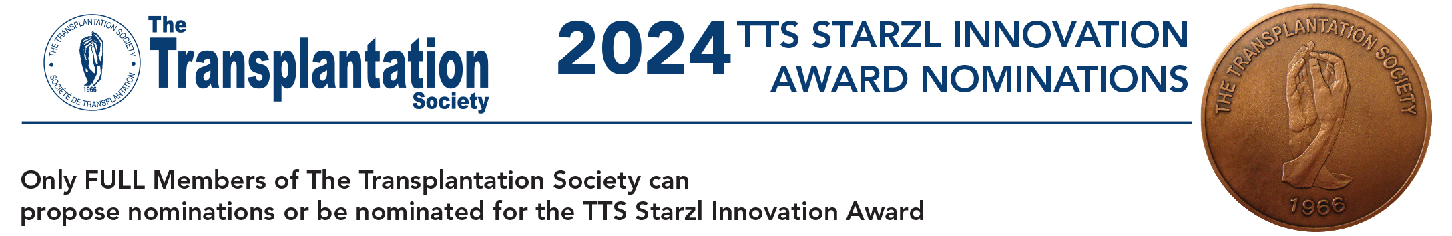

Email this completed form to: nominations@tts.org

PLEASE SEND THE COMPLETED FORM NO LATER THAN APRIL 8, 2024

1. NOMINEE DETAILS:

Name of Nominee:
Professional title and afﬁliation of Nominee:
Business Address:
Telephone:
Email:

2. NOMINATOR DETAILS:

Name of Nominator:
Professional title and afﬁliation of Nominator:
Business Address:
Telephone:
Email:
Signature:

3. A statement highlighting the significant contributions to the field of transplantation by the nominee. (Not to exceed 250 words):

4. A brief curriculum vitae or biographical sketch of the nominee. (Not to exceed 500 words):

5. A list containing the most signiﬁcant scientiﬁc publications relevant to the nominee (not to exceed 10 citations). Please include the authors (with the name of the nominee in Bold, title, journal, year, volume and pages).

