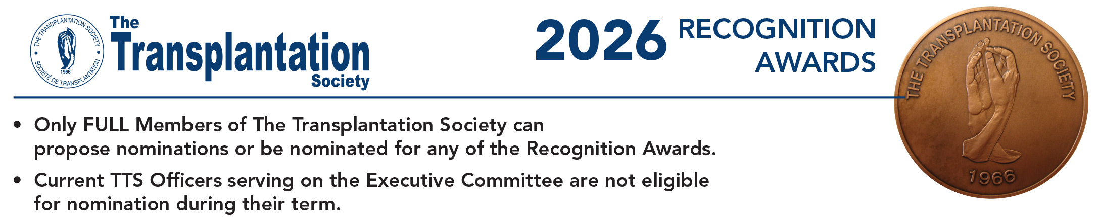

Email this completed form to: nominations@tts.org

PLEASE REMIT FORM NO LATER THAN MAY 18, 2026

1. NOMINEE DETAILS:

Name of Nominee:
Professional title and afﬁliation of Nominee:
Business Address:
Telephone:
Email:

2. NOMINATOR DETAILS:

Name of Nominator:
Professional title and afﬁliation of Nominator:
Business Address:
Telephone:
Email:
Signature:

3. AWARD (choose 1 from the following):

   Outstanding Achievement Transplantation Science (Basic)
   Outstanding Achievement in Transplantation Science (Clinical)
   Outstanding Achievement in Transplantation Science (Developing Country)
   Mentorship or Education and Training in Transplantation

4. A statement highlighting the principal achievements of the nominee as it pertains to the award selected above. (Not to exceed 250 words):

5. A brief curriculum vitae or biographical sketch of the nominee. (Not to exceed 500 words):

6. If one of the first 3 awards was selected, please provide a list containing the most signiﬁcant scientiﬁc publications relevant to the nominee (not to exceed 10 citations). Please include the authors (with the name of the nominee in Bold, title, journal, year, volume and pages).

